What is a Vector?

A Vector is a sequence of numbers.

Vector Operations

Addition / Subtraction

You can only add or subtract vectors if they have the same dimension.  
If you want to add the 2 vectors below you must do the operation to each number in the vector. In this example its „3+(-2)“, „4+4“ and „-2+7“ which gives you the final vector „(1,8,5)“.

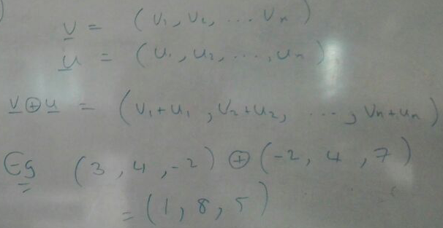

With this basic calculation, you can calculate a vector get you from one point to another point.  
If you want to know who to go from Vector U to Vector V you just have to subtract Vector U from Vector V and the result is your way to go.

Scalar Multiplication

If you want to keep a direction but you want to scale the size, scalar multiplication is the way to do it.  
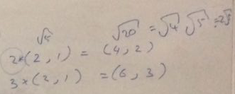

You basically just multiply every value with the number of times you want it to multiply.  
“2x(2,1)” will be “(2x2, 2x1)” will be “(4,2)”.

Magnitude and angles

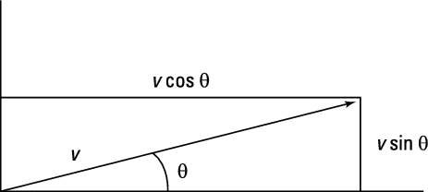  
src: <http://www.dummies.com/education/science/physics/how-to-find-a-vectors-magnitude-and-direction/>

If you want to get the magnitude of a Vector you can use the Pythagorean theorem. If your Vector “(x,y)” is “(3,4)” then you just have to follow this formula:

 => 

For the angle, you can transform this formula:

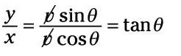 to to 

Or you can use this formula to check if, for example, a rouge is behind his victim.

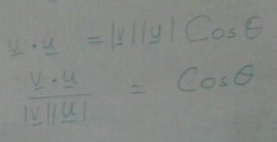

With this formula the angle is the cosines

Let v be (1,2,3) and u be (6,5,4) we can write  
  
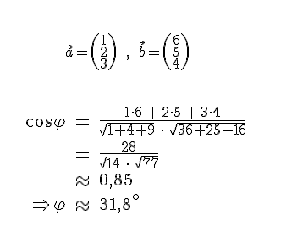

Src: <http://www.rither.de/a/mathematik/lineare-algebra-und-analytische-geometrie/winkel/winkel-zwischen-vektor-und-vektor/>

It may happen that it will look like this in the exam:

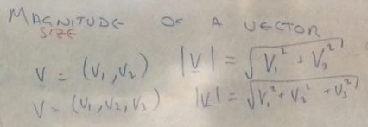

Normal Vector

The normal Vector is a Vector perpendicular to the surface at a given point.  
The way we learned to normalize a vector was to square all the values, add them together, get the square root and then multiplied “1/result” with the given vector.

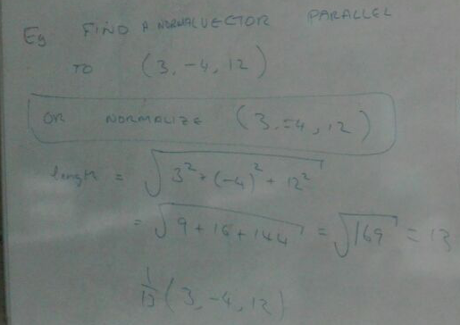

Length of a Vector

If you want to know how many units a vector has, you can just use the formula from above and stop after getting the square root. For example, if the Vector is (1,2,2) you can calculate the length this way: 

Rays

If you want to use a ray to check if something like (-6, 11, 0) is between the origin (2,3,4) and the direction (-2, 2, -1) you have to add the direction multiple times to the origin till you hit or pass the point of interest.  
For this example you do like this:  
  
hit = origin + loop times \* direction  
T=0 (2,3,4) = (2,3,4) + 0 \* (-2, 2, -1) => now you check if hit equals your target or passed it  
 (2,3,4) != (-6,11,0) && 2 > -6 => keep trying

T=1 (0, 5, 3) = (2, 3, 4) + 1 \* (-2,2, -1) || no match, keep trying

T=2 (-2, 7, 2) = (2, 3, 4) + 2 \* (-2,2, -1)

T=3 (-4, 9, 1) = (2,3,4) + 3 \* (-2,2, -1)

T=4 (-6, 11, 0) = (2, 3, 4) + 4 \* (-2, 2, -1) || match, it’s on the point

If T=4 would be some think like (-6, 10, 0) we could also stop because every point must match and if one point match and no other than the vector is not on the ray.

